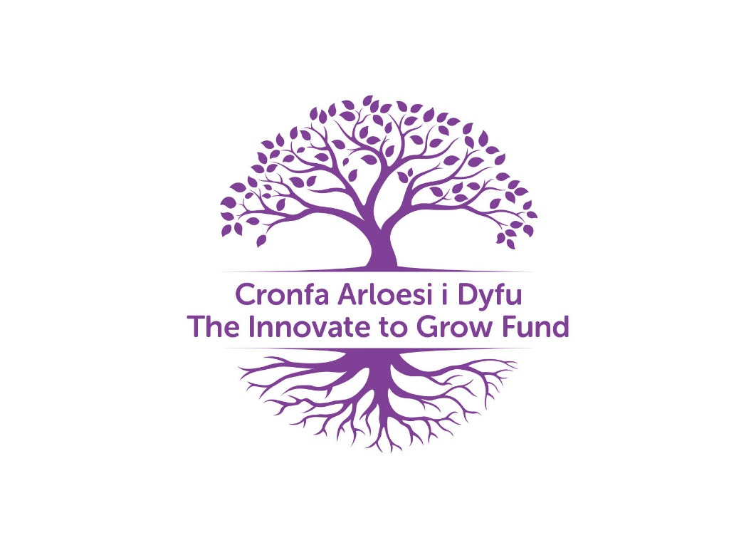

The Police and Crime Commissioners
Innovate to Grow Fund

The Police and Crime Commissioner Andrew Dunbobbin is launching a new scheme which will target new initiatives across North Wales that will compliment the Police and Crime Plan priorities and his Community Oriented Police Service (COPS) approach to serve all communities across north Wales.
Delivering Safer Neighbourhoods
- Tackle and prevent rural and wildlife crime
- Improve the efficiency and effectiveness of police officers and police staff
- Improve Road safety

Supporting Victims and Communities
- Tackle and prevent domestic abuse and sexual violence
- Safeguard vulnerable people including children
- Tackle and prevent cybercrime
- Establish a victim’s panel
- Tackle and prevent Hate Crime

Fair and Effective Criminal Justice System
- Introduce a North Wales Female Offender Strategy
- Increase the use of Restorative Justice
- Support and protect children and young people and divert them away from the Criminal Justice System
- Address the root causes of offending and support the rehabilitation of people who have offended

The Commissioner recognises the importance of small investments to deal with root causes and is keen to invest in projects that demonstrate new and innovative ideas to prevent and tackle crime across north Wales.
The Commissioner has allocated £100,000 to the new scheme to support projects for up to 1 year with the main focus being on innovation. A maximum of £5k will be available for each project however should the project be delivered across 2 or more counties a maximum of £10k will be offered.
Eligibility and Funding Criteria
To be eligible for funding, applicants must complete a business plan. To be considered by the panel the business plan must align to one of the Commissioners policing priorities. All organisations will need to ensure they have a Welsh Language, Equal Opportunities and Social Value policy in place and how they will be integrating these areas into the delivery of the project. All applications must include an exit strategy due to the funding only being available for 1 year. In addition, it is preferred that project includes an element of match funding however this is not essential.
Exclusions
The grant cannot be used to fund an individual or organisations established to make profit.
Timescales
The OPCC will be welcoming business cases throughout 2022-2023. Once business cases are submitted a panel will review and appraise each application against a set criteria to determine whether to issue funding and if successful originations will be issued terms and conditions for 1 year from the date of approval. All successful and unsuccessful applicants will be informed within 7 working days of the panel meeting. All decisions and a brief summary of the rational will be published to the OPCC website following the panel meeting along with Decision Notices.
Please note all business cases must be returned to Commissioning Assistant, Hannah Roberts (Hannah.roberts@northwales.police.uk).

